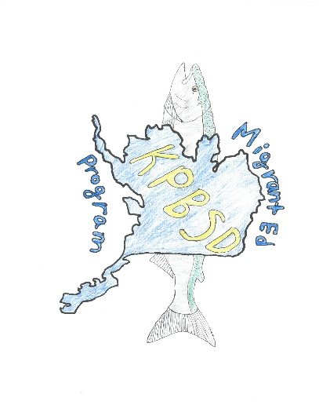
KPBSD Migrant Education Program
Seasonal Work Survey
Please take time to complete this quick survey. All of your answers will be kept confidential. The information you provide may help our district qualify for federal funding to provide more education services to our students.
- Within the past three years, has anyone in your family engaged in any of the following activities:
____ Commercial Fishing ____ Logging (with a logging company)
____ Subsistence Fishing _____ Agriculture (may include berry picking in some instances)
- Did the activity require being away from your residence for a total of 7 nights/8 days over the course of a year?
YES NO
- If yes, did the activity require travel that either crossed school district boundaries or was at least 20 miles, one way, away from your residence?
YES NO
- Is the activity an economic necessity for your family, meaning you need the income, harvest or catch to meet your household’s most basic needs? YES NO
If you did not select an activity or answered NO to questions 2, 3 or 4,
you do not need to continue and may discard this survey.

If you selected an activity and answered YES to questions 2-4, please complete the contact information below.

Name: ___________________________________
Phone number: ____________________________
Names of children who traveled for the activity: ___________________________________________________
___________________________________________________________________________________________
Dates away from residence: ___________________________________________________________________
Are any of your children currently enrolled in the Migrant Education Program? YES NO
PLEASE BE PREPARED TO PROVIDE DETAILS REGARDING THE ACTIVITY, INCLUDING LOCATION, GEAR AND CATCH/HARVEST

Return this form to your school secretary
KPBSD Migrant Education Program
148 N Binkley St
Soldotna, AK 99669
Forms can be scanned to msnell@kpbsd.k12.ak.us

or mail or scan to:

